Key Concepts
Distinction between Authentication and Authorization
Authentication validates user identity, while authorization controls resource access. A user might be authenticated but still lack permissions to do anything.
Role-Based Access Control (RBAC) in Kubernetes
RBAC is implemented using two main Kubernetes objects:
  - Role (Ro): Defines permissions on resources within a namespace. Not applied on cluster level.
  - RoleBinding: Assigns a Role to a specific user or group, enabling authorization.
API Groups in Kubernetes
  - Core API Group (no prefix): Includes resources like Pods/Services/ConfigMaps (apiVersion: v1).
  - Named API Groups: Include resources like Deployments/ReplicaSets under apps(apps/v1) or Roles/RoleBindings/ClusterRoles under rbac.authorization.k8s.io (rbac.authorization.k8s.io/v1) or
Jobs/CronJobs under batch (batch/v1).
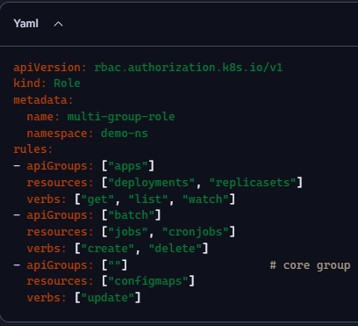
RBAC Role YAML
  - apiVersion, kind: Role, and metadata (can bind to a namespace here). If namespace is not specified, it applies to all namespaces, and so becomes cluster scoped.
  - rules: Specify API groups (“” = core API group), resources (e.g., pods), and verbs (actions like get, watch, list).
  - Example: 1st rule grants read-only access to deployments, replicasets.

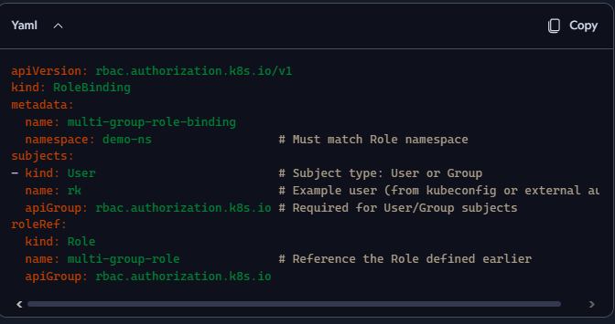
RoleBinding YAML
  - Binds a Role to a user (e.g., rk).
  - Specifies subject (who gets the permissions) -> kind (User), name, and API group (which API group defines the subject type).
  - Defines the role reference (which Role to bind).

Workflow and Commands
Step | Description / comments | Example Command(s)
Check which user and if user has access for any operation | Cluster admin can impersonate any user. | Kubectl auth whoami (shows username and groups)  kubectl auth can-i get pods  kubectl auth can-i get pods --as=adam (impersonate Adam)
Create Role (read pods) | Apply Role YAML manifest | kubectl apply -f role.yaml
View Role(s) | List and describe roles | kubectl get roles  kubectl describe role <role-name>
Create RoleBinding | Apply RoleBinding YAML manifest binding Role to user | kubectl apply -f rolebinding.yaml
Verify RoleBinding | List and describe RoleBindings | kubectl get rolebinding / kubectl describe rolebinding <name>
Switch user context | Configure kubectl credentials and context for user | kubectl config set-credentials rk--client-certificate=rk.crt –client-key=rk.key  kubectl config set-context rk-context --cluster=my-cluster --namespace=default –user=rk  kubectl config use-context rk-context
Check current user |  | kubectl config current-context  kubectl auth whoami
- kubectl config view - shows data of default kubeconfig file.

Additional Topics
- Imperative Creation of Roles and Bindings
Using commands like:
kubectl create role pod-reader --verb=get --verb=list --verb=watch --resource=pods kubectl create rolebinding pod-reader-binding --role=pod-reader --user=krishna
- Kubernetes REST API Access Using curl
  - Making API calls programmatically using certificates.
  - Example curl command includes passing client key, certificate, and CA certificate.
  - The response is JSON formatted, equivalent to kubectl get pods.

Summary of Process
Action | Description
Create new user (e.g., rk) | Generate key, CSR, and certificate; encode CSR; apply CSR to Kubernetes
Approve CSR. Get certificate. | Admin approves the certificate signing request. Export certificate from CSR object, Decode and shares with user.
Create Role | Define permissions (e.g., read pods only)
Create RoleBinding | Bind Role to the user
Update kubeconfig | Set user credentials and context
Switch context | Use new user context to verify access
Test access | Confirm allowed and forbidden resource access

Important Notes and Recommendations
- Certificate management is crucial; expired certificates cause access failures.
- Role and RoleBinding objects control authorization and must be configured properly.
- Impersonation commands allow admins to test user permissions without switching contexts.
- Kubectl config management enables handling multiple users and contexts effectively.
- REST API calls to Kubernetes require appropriate certificates for authentication.

